Executive summary
I analyzed the FTE REQ data from October 2024 through July 2027. Project-level rows were aggregated to the individual account, site, and skillset level
For this analysis, IND WAH was treated as a flexible India-wide pool and PHL WAH as a flexible Philippines-wide pool. Seasonal patterns were evaluated only for combinations with at least 18 months of history.
The strongest recurring seasonal signals were:
- December peaks were the most common, appearing in 19 active account/site/skillset combinations
- September peaks appeared in 15 combinations
- July and January peaks appeared in 14 and 13 combinations
- May and July troughs were the most common, each appearing in 17 combinations
- June and September troughs appeared in 14 and 13 combinations
This suggests meaningful opportunities to move trained capacity between accounts during the December-January, May-July, and September-October seasonal transitions.
Download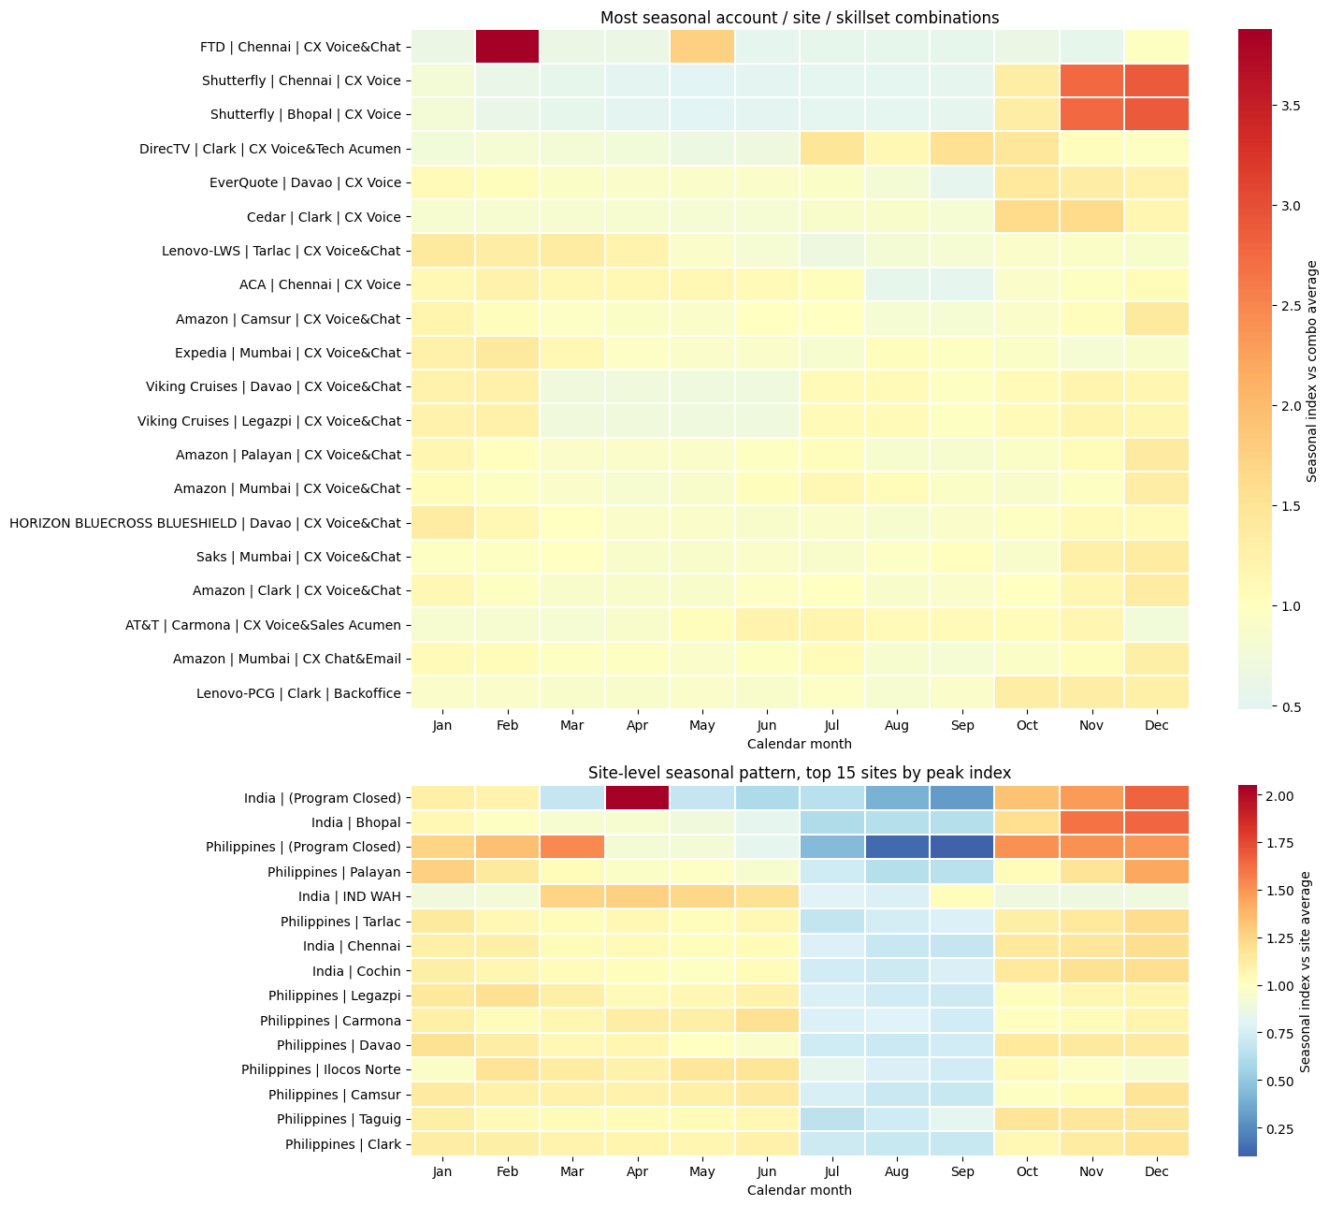
Account/site seasonal variation
The table below ranks active combinations by seasonal swing. Swing vs avg is the difference between the average seasonal peak and trough divided by the average FTE requirement.
The most pronounced patterns are:
FTD in Chennai
FTD | Chennai | CX Voice&Chat has the largest relative seasonal swing.
- Peak in February
- Trough in June
- Average requirement of approximately 49 FTE
- Peak requirement of approximately 183 FTE
- Trough requirement of approximately 26 FTE
- Peak-to-trough gap of approximately 157 FTE
This is an especially strong candidate for seasonal redeployment into FTD during February and out of FTD during June.
Shutterfly in Chennai and Bhopal
Both Shutterfly combinations show nearly identical patterns.
- Peak in December
- Trough in May
- Chennai average of approximately 83 FTE
- Bhopal average of approximately 51 FTE
- Chennai peak-to-trough gap of approximately 191 FTE
- Bhopal peak-to-trough gap of approximately 117 FTE
The matching pattern across Chennai and Bhopal suggests Shutterfly demand is structurally seasonal rather than site-specific.
December concentration in Amazon and other CX programs
Several large CX Voice&Chat and CX Chat&Email programs peak in December.
Examples include:
- Amazon in Camsur
- Amazon in Palayan
- Amazon in Mumbai
- Amazon in Clark
- Amazon in Hyderabad
- Saks in Mumbai
- Shutterfly in Chennai and Bhopal
These December peaks are valuable for load balancing because other accounts often reach their troughs around April, May, July, August, or September.
Philippines seasonal patterns
The strongest Philippines examples include:
- DirecTV | Clark | CX Voice&Tech Acumen peaking in September and troughing in May
- EverQuote | Davao | CX Voice peaking in October and troughing in September
- Cedar | Clark | CX Voice peaking in October-November and troughing in May
- Lenovo-LWS | Tarlac | CX Voice&Chat peaking in January and troughing in July
- Amazon | Camsur | CX Voice&Chat peaking in December and troughing in September
- HORIZON BLUECROSS BLUESHIELD | Davao | CX Voice&Chat peaking in January and troughing in August
The Philippines has several useful complementary windows, particularly where December-January peaks coincide with August-September troughs.
Complementing account patterns and load-balancing options
The following recommendations use three rules.
First, the donor and receiving account must be in the same site, or one of them must be a WAH pool within the same country.
Second, the donor skillset must contain the required target skillset. For example, a CX Voice&Chat agent is considered compatible with a CX Voice requirement.
Third, the suggested transfer is capped by both the receiver's seasonal uplift and the donor's estimated slack during the same months. These are planning quantities based on historical averages, not guaranteed staffing availability.
0 cols, 0 rows returned
No rows to display
Highest-value recommendations
1. Fiserv Hyderabad to receive Airbnb Hyderabad CX Voice&Chat capacity
Fiserv | Hyderabad | CX Voice shows peaks in January, February, and December.
Airbnb | Hyderabad | CX Voice&Chat has enough relative slack during those months to support Fiserv.
Suggested action
- Cross-skill approximately 16 FTE from Airbnb to support Fiserv during January, February, and December
- Use CX Voice&Chat agents because that skillset contains CX Voice
- Pre-train or certify the transferred agents before the December ramp
This is one of the clearest examples of a smaller seasonal CX Voice program being supported by a much larger, compatible CX Voice&Chat operation.
2. Shutterfly Chennai to receive support from FTD and Expedia Chennai
Shutterfly | Chennai | CX Voice peaks in October, November, and December and has an estimated seasonal uplift of approximately 105 FTE above its average requirement.
Potential donors include:
- FTD | Chennai | CX Voice&Chat with approximately 13 FTE of estimated slack
- Expedia | Chennai | CX Voice&Chat with approximately 19 FTE of estimated slack
Suggested action
- Cross-skill approximately 13 FTE from FTD
- Cross-skill approximately 19 FTE from Expedia
- Use the combined pool of approximately 32 FTE to cover the first layer of the Shutterfly seasonal ramp
- Cover the remaining requirement through temporary hiring, overtime, or a broader Chennai CX Voice&Chat pool
This is directionally consistent with the example in the request. The donor accounts have compatible skills and are relatively less loaded during Shutterfly's October-December peak.
3. McAfee Chennai to receive FTD Chennai capacity
McAfee | Chennai | CX Voice has a broad peak from October through March.
FTD | Chennai | CX Voice&Chat has usable slack during part of this period.
Suggested action
- Cross-skill approximately 12 FTE from FTD to McAfee
- Prioritize October through December first
- Treat January through March as a secondary deployment window because the FTD pattern also rises toward February
This transfer should be coordinated carefully with FTD's February peak.
4. McAfee Clark to receive Cedar Clark capacity
McAfee | Clark | CX Voice has a strong peak during October through March.
Cedar | Clark | CX Voice&Chat has compatible capability and lower estimated demand during the same period.
Suggested action
- Cross-skill approximately 6 FTE from Cedar to McAfee
- Use the transfer primarily during October through December
- Return the capacity to Cedar before Cedar's March requirements increase
5. Fiserv Clark to receive AT&T Clark capacity
Fiserv | Clark | CX Voice peaks during October and November.
AT&T | Clark | CX Voice&Sales Acumen has compatible CX Voice capability and estimated slack during those months.
Suggested action
- Cross-skill approximately 38 FTE from AT&T to Fiserv during October and November
- Keep the transfer limited to agents certified for CX Voice
- Avoid moving the full amount if Sales Acumen work is also time-sensitive
6. Lenovo-LWS Tarlac and Fiserv Tarlac as complementary CX programs
Fiserv | Tarlac | CX Voice peaks in October through December, while Lenovo-LWS | Tarlac | CX Voice&Chat peaks in January and reaches a trough in July.
Suggested action
- Use Lenovo-LWS capacity for Fiserv during October through December
- Plan for approximately 5 FTE of transferable capacity from Lenovo-LWS
- Consider using Fiserv agents to support Lenovo-LWS during the January peak only if CX Voice&Chat certification is available
This is a modest opportunity in absolute FTE terms, but it has a clean seasonal handoff.
7. Amazon Camsur to receive TripAdvisor Camsur capacity
Amazon | Camsur | CX Voice&Chat peaks in January and December.
TripAdvisor | Camsur | CX Voice&Chat has estimated slack during those months.
Suggested action
- Cross-skill approximately 41 FTE from TripAdvisor to Amazon during December and January
- Use this as a Camsur site-level flex pool
- Protect TripAdvisor's own higher-demand months before finalizing the transfer
8. Amazon Hyderabad and Block Hyderabad as a CX Chat&Email exchange
The two accounts have complementary patterns.
- Amazon Hyderabad CX Chat&Email peaks in December
- Block Hyderabad CX Chat&Email peaks during July through September
- Both have the same skillset
Suggested action
- Move approximately 76 FTE from Block to Amazon for the December peak
- Move approximately 67 FTE from Amazon to Block during July through September
- Establish a standing Hyderabad CX Chat&Email flex pool rather than treating this as a one-time transfer
This is one of the strongest reciprocal load-balancing opportunities because the skillsets match exactly and the peak windows are separated.
Recommended operating model
Chennai
Chennai has the strongest cross-account opportunities for:
- CX Voice between Shutterfly, McAfee, FTD, Expedia, and WEX
- CX Voice&Chat between FTD, DHL, Expedia, and Amazon
- December support for Shutterfly and Amazon programs
- February support for FTD and ACA
A practical Chennai model would create a seasonal CX Voice and CX Voice&Chat flex pool that is built up during May-June trough periods and deployed during October-February peaks.
Hyderabad
Hyderabad has strong opportunities across:
- Fiserv CX Voice
- Airbnb CX Voice&Chat
- Amazon CX Voice&Chat
- Block and Amazon CX Chat&Email
- Checkr and Wayfair CX Voice&Chat
The most attractive structure is a reciprocal CX Chat&Email pool between Amazon and Block, combined with CX Voice&Chat cross-training between Airbnb, Amazon, Checkr, and Wayfair.
Clark
Clark has substantial scale and several compatible CX Voice programs.
Priority opportunities include:
- McAfee supported by Cedar, AT&T, TripAdvisor, or Block
- Fiserv supported by AT&T
- PNC supported by McAfee
- Amazon and TripAdvisor as a CX Voice&Chat flex pair
Because Clark contains large accounts, even a small percentage of cross-trained capacity can produce material FTE coverage.
Tarlac
Tarlac has useful skill alignment across:
- Fiserv CX Voice
- Lenovo-LWS CX Voice&Chat
- Amazon CX Voice&Chat
- AT&T and T-Mobile Tech Acumen
The strongest opportunities are seasonal handoffs between the Fiserv and Lenovo-LWS programs, plus a Tech Acumen exchange between AT&T and T-Mobile.
Davao and other Philippines sites
Davao has opportunities involving:
- EverQuote CX Voice
- Viking Cruises CX Voice&Chat
- HORIZON BLUECROSS BLUESHIELD CX Voice&Chat
The most useful planning window is to redeploy capacity from programs troughing in May-August into programs peaking in January-February or October.
Important planning caveats
The transfer amounts should be treated as initial planning recommendations, not final staffing commitments.
Before executing, validate each recommendation against:
- Actual FTE Ava
- Agent certification and nesting time
- Language or account-specific knowledge requirements
- Work-hour and schedule compatibility
- Service-level targets
- Whether the seasonal pattern is caused by a short-term ramp or a permanent program change
The strongest immediate opportunities are the Amazon-Block Hyderabad CX Chat&Email exchange, Shutterfly Chennai support from FTD and Expedia, Fiserv Hyderabad support from Airbnb, and the Clark CX Voice network across McAfee, Cedar, AT&T, Block, and TripAdvisor

